SQL PRACTICE NOTES - ORDERS TABLE

1: CREATE TABLE

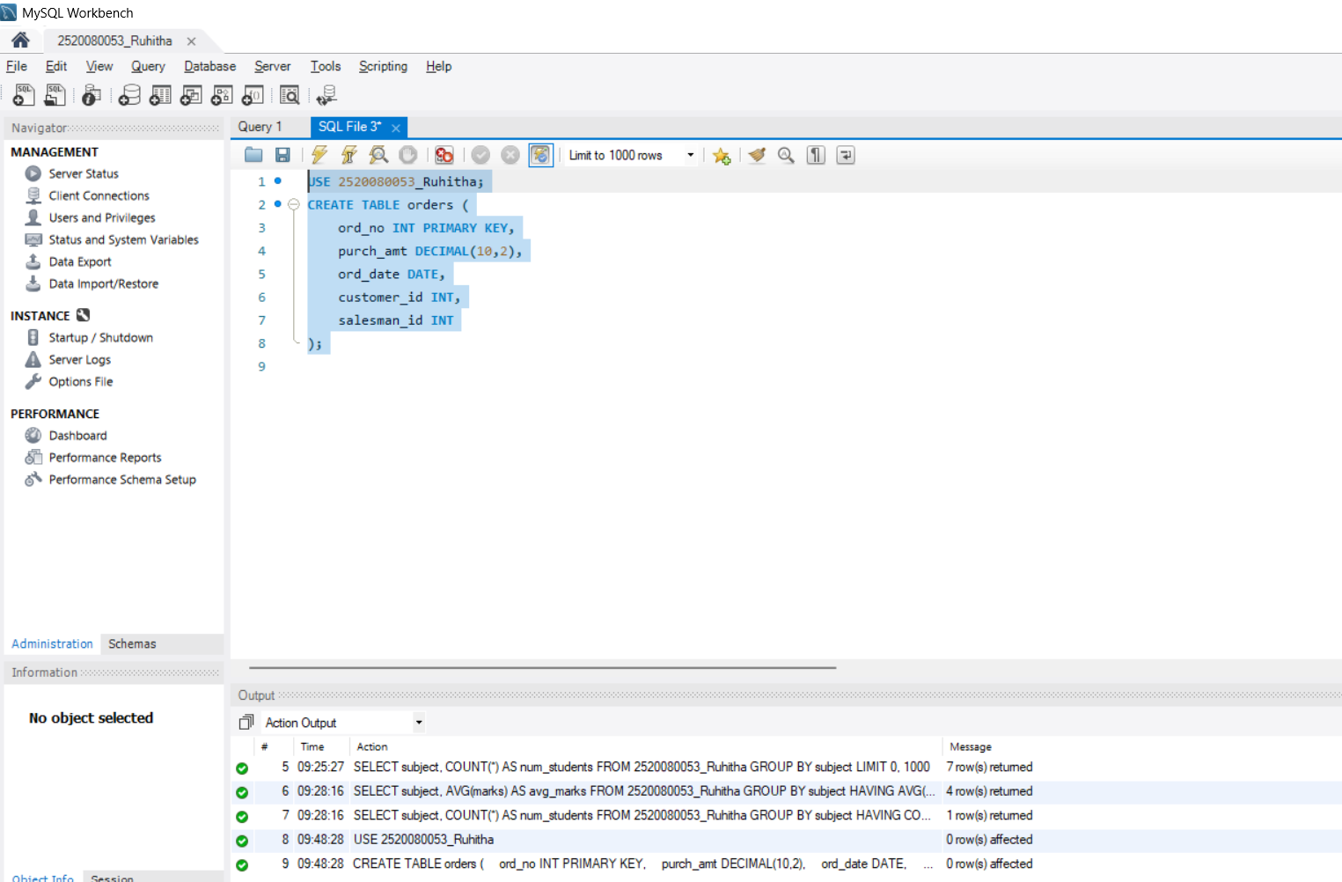

2: INSERT DATA
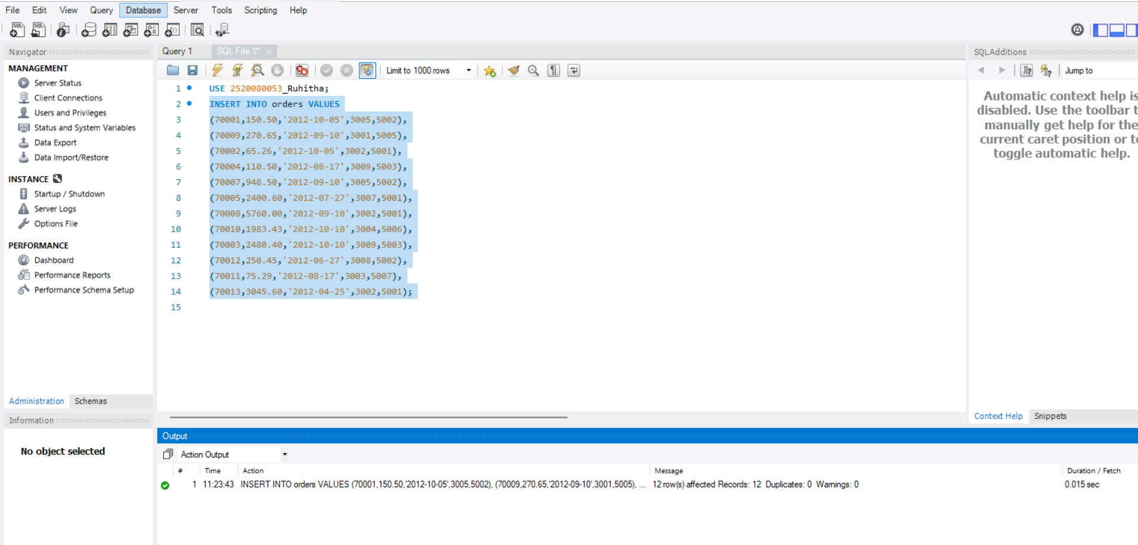
3.WHERE CLAUSE
SCENARIO:
Finance wants all orders whose purchase amount is greater
than $2,000.

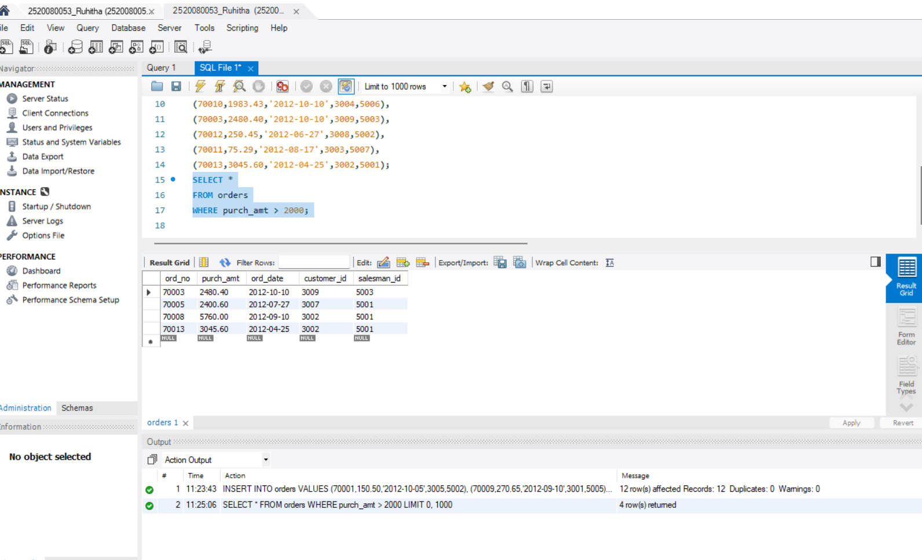

SCENARIO:
Management wants all orders placed on 2012-09-10.

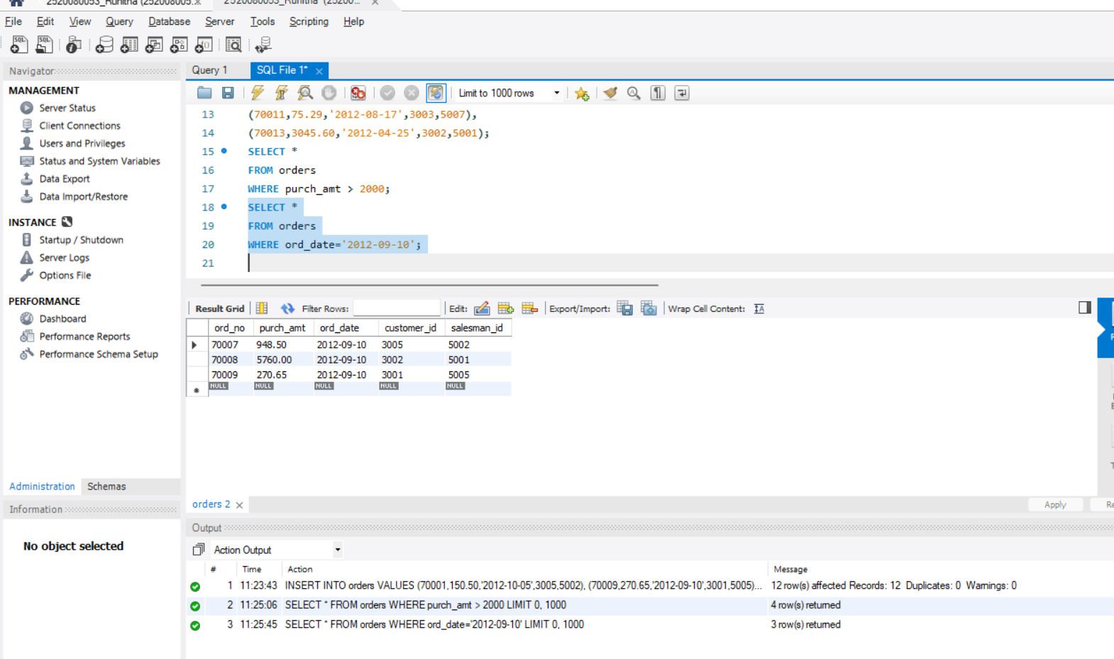

SCENARIO:
Find all orders handled by salesman 5001.

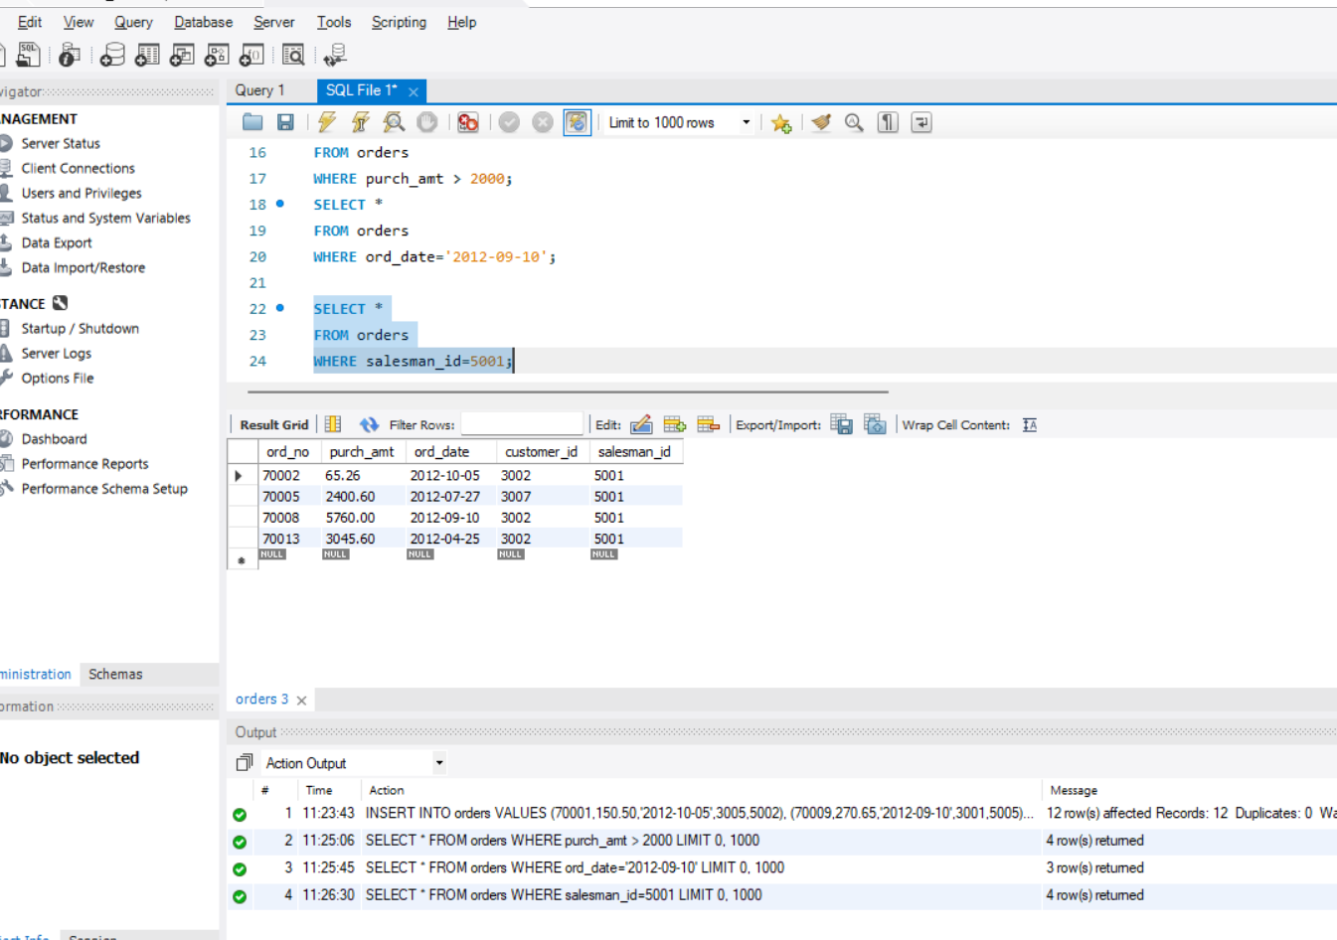

SCENARIO:
CEO wants to see orders ranked from highest amount to
lowest amount.
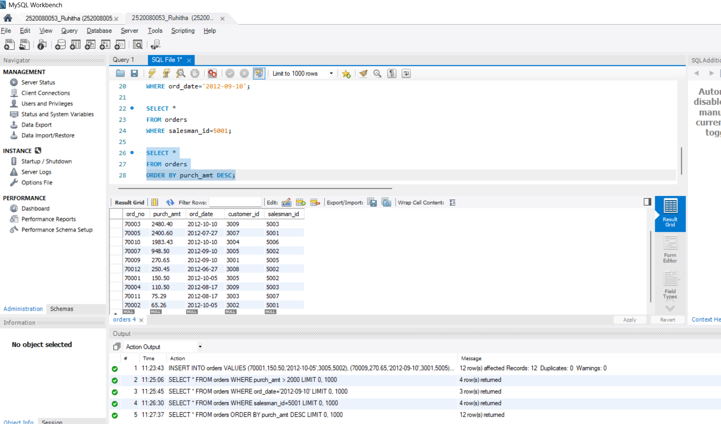
SCENARIO:
Operations team wants oldest orders first.
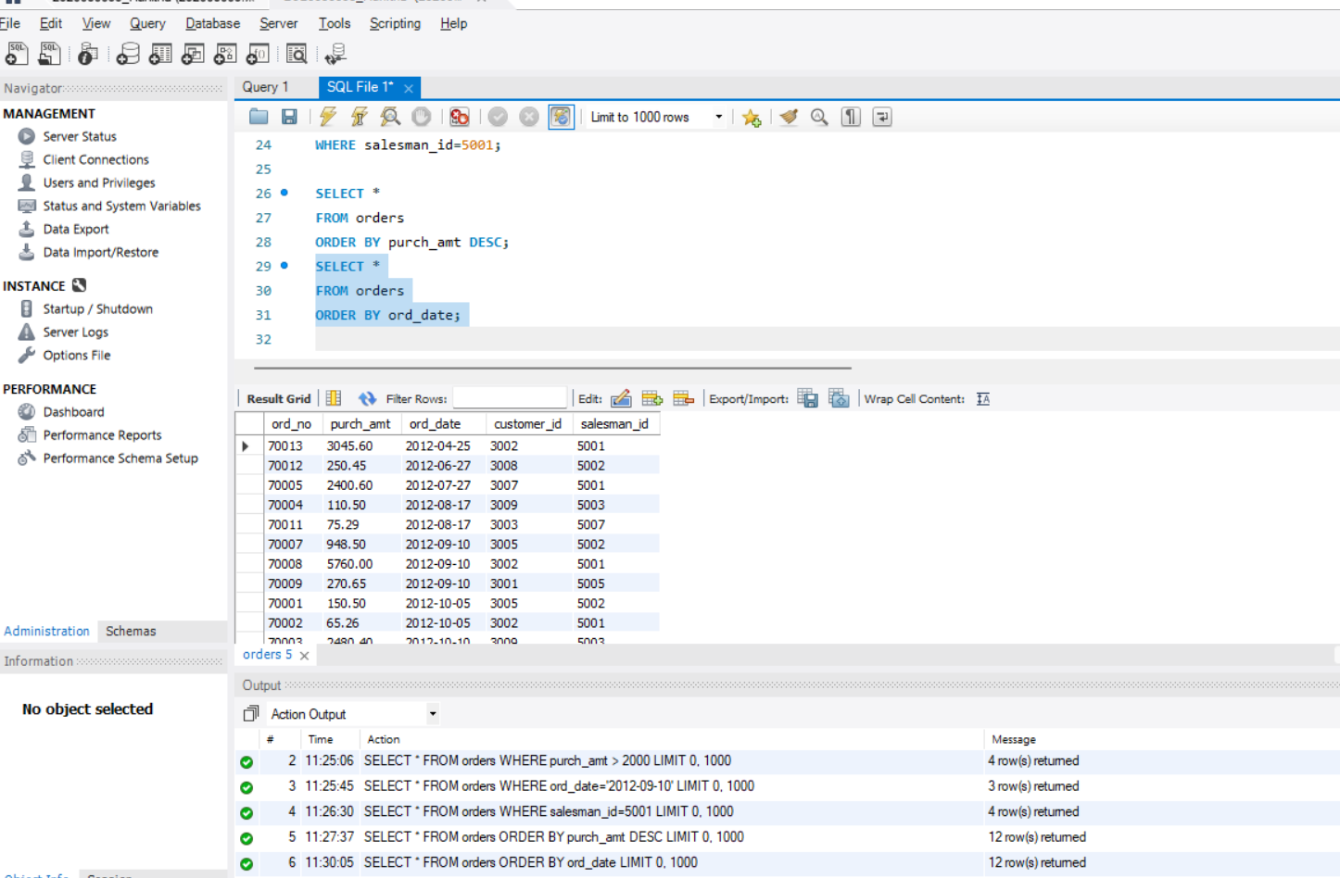
SCENARIO:
Finance department wants total revenue generated.
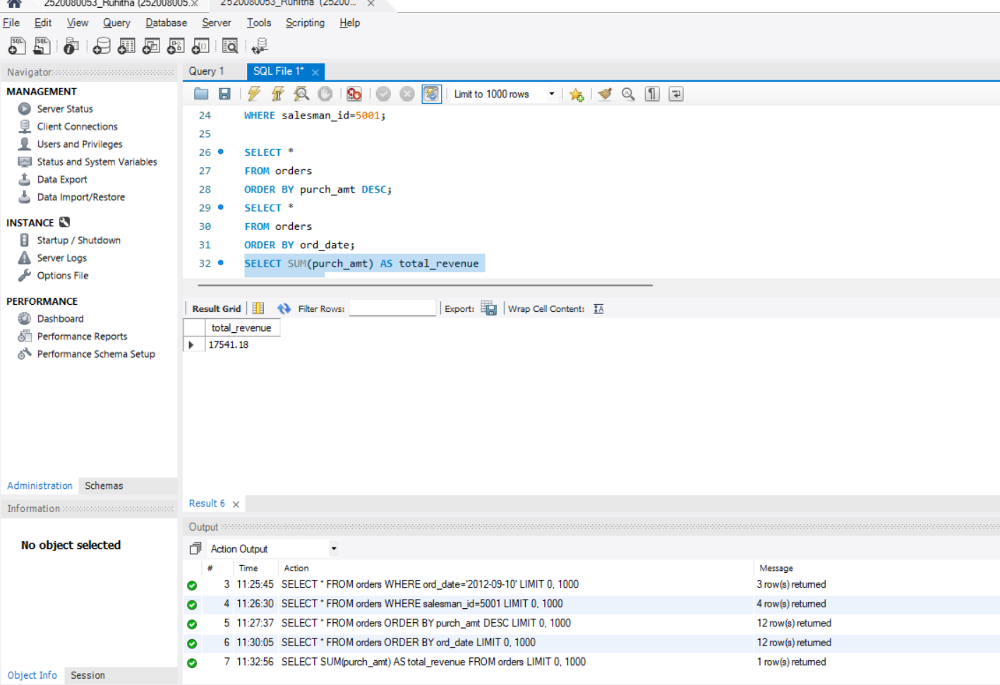
SCENARIO:
Management wants average order value.

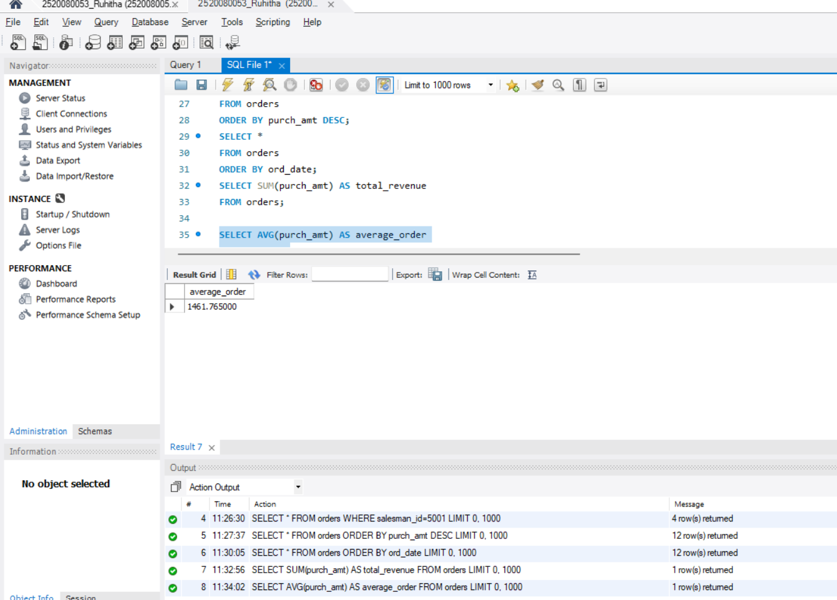

SCENARIO:
Find the highest order amount.

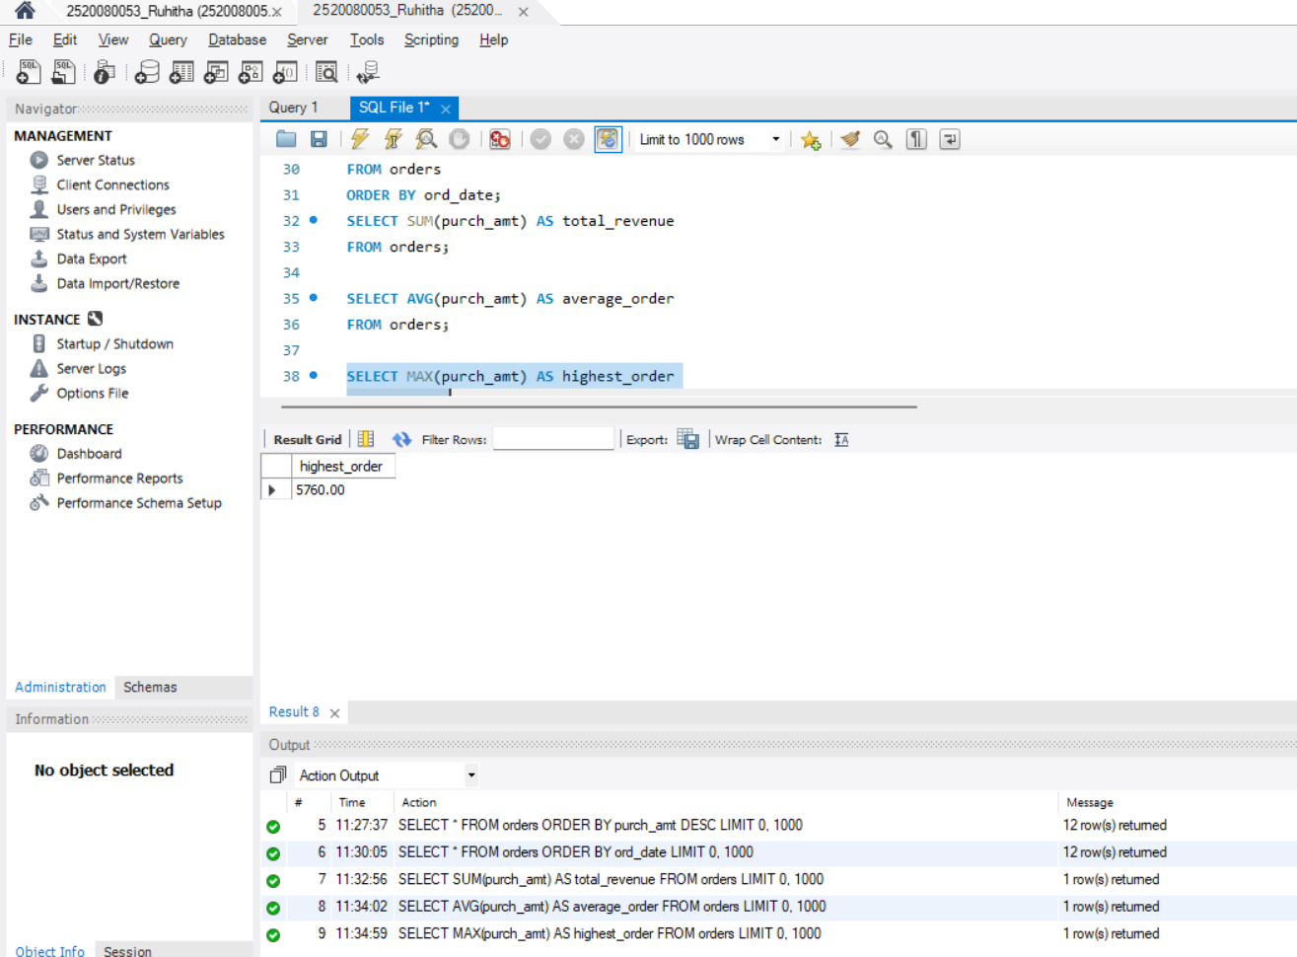
SCENARIO:
Find the lowest order amount.
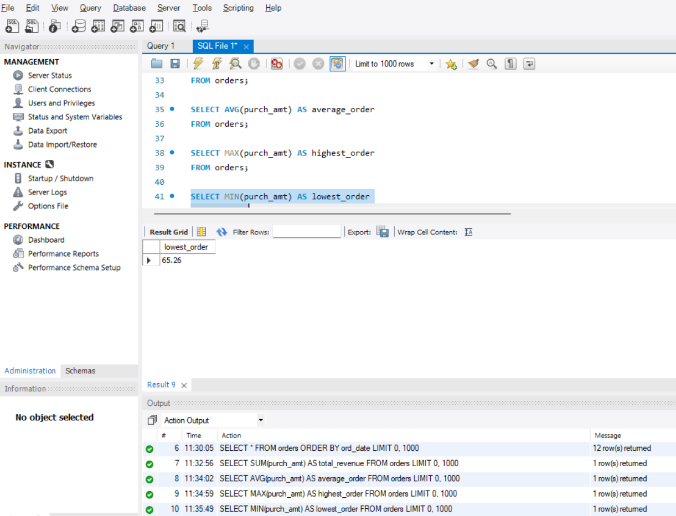

SCENARIO:
Find total number of orders.
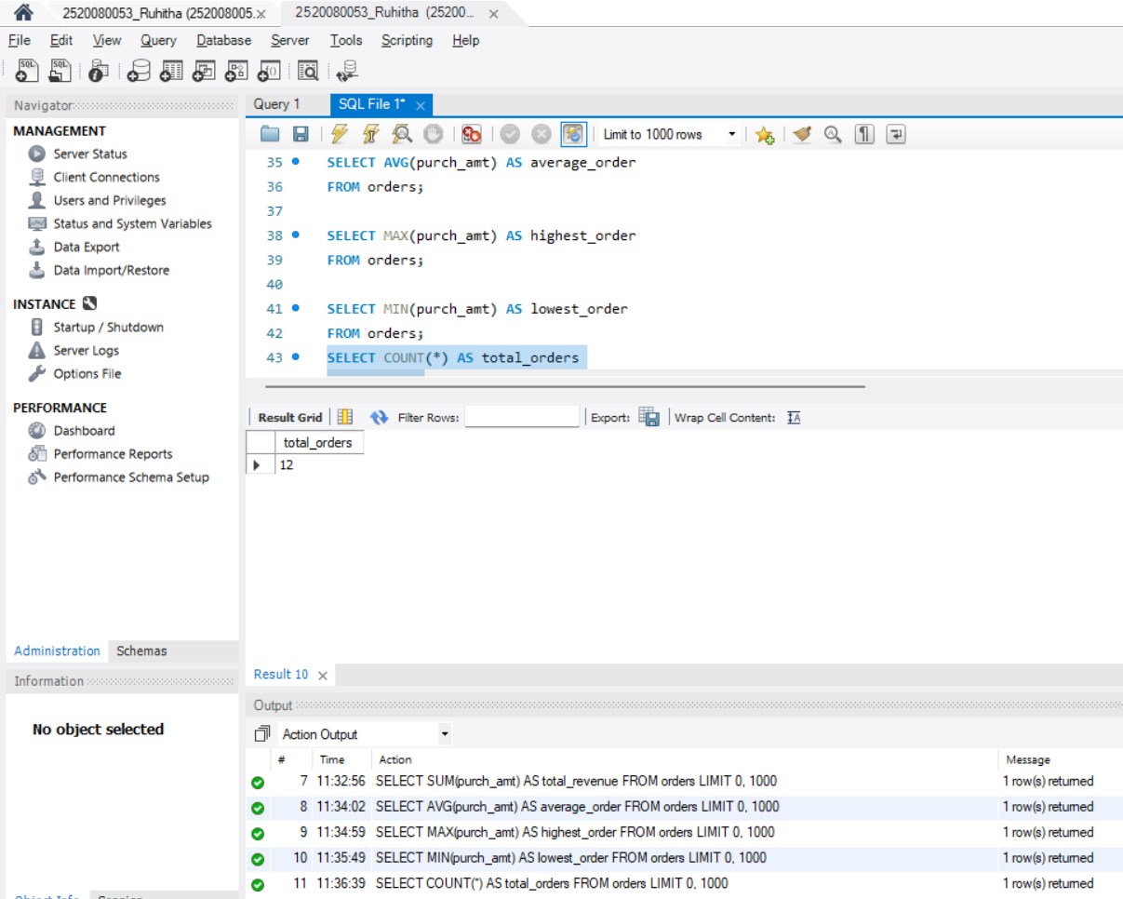
SCENARIO:
Sales director wants total sales generated by each
salesman.

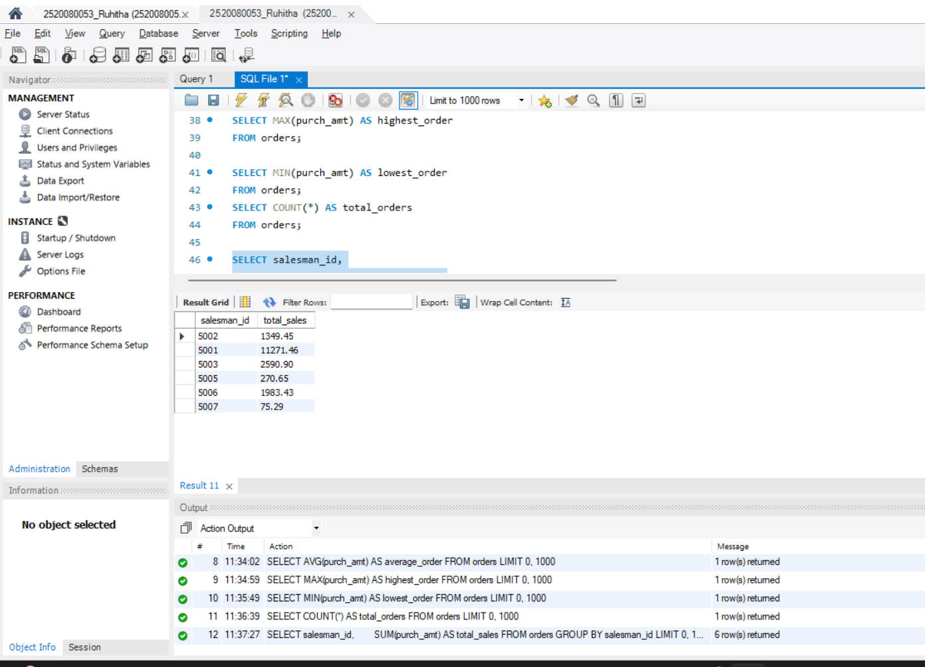
SCENARIO:
Marketing wants total purchases made by each customer.
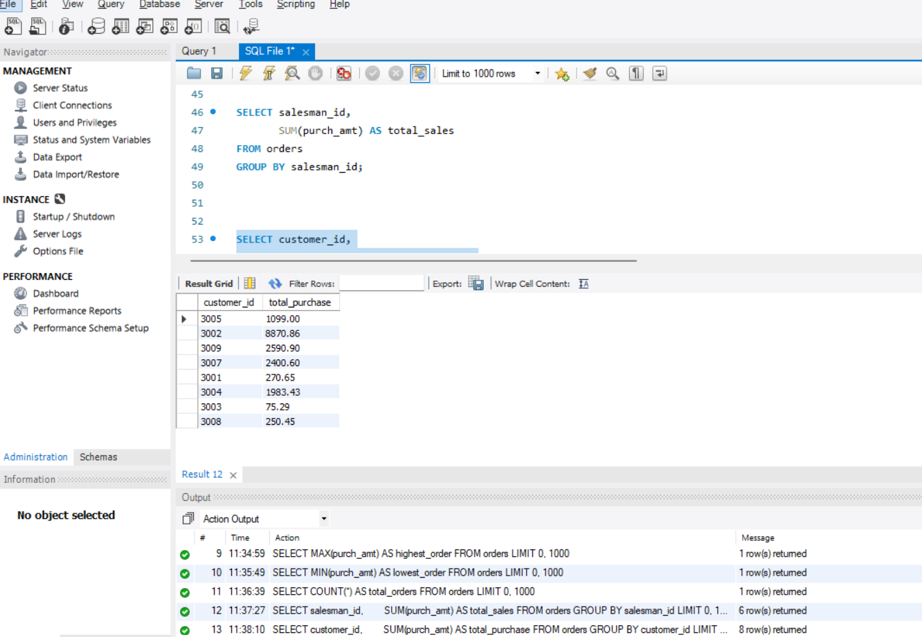
SCENARIO:
Find the highest order placed by each customer.
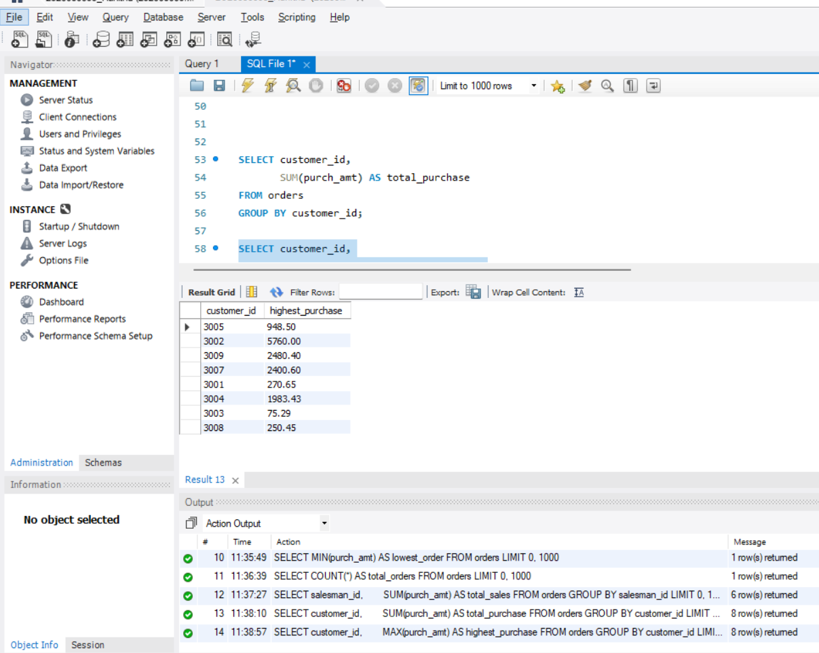
SCENARIO:
Company rewards salesmen whose total sales exceed $3,000.
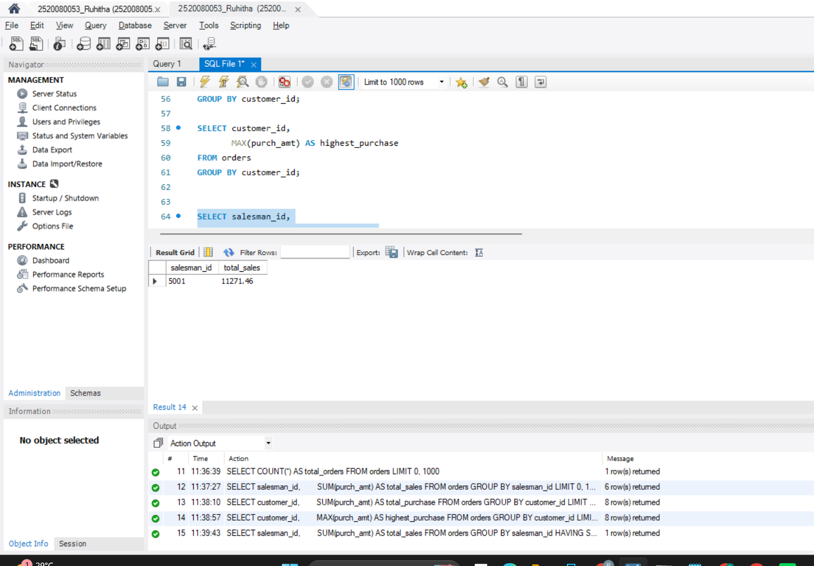
SCENARIO:
Find customers whose total purchases exceed $2,500.
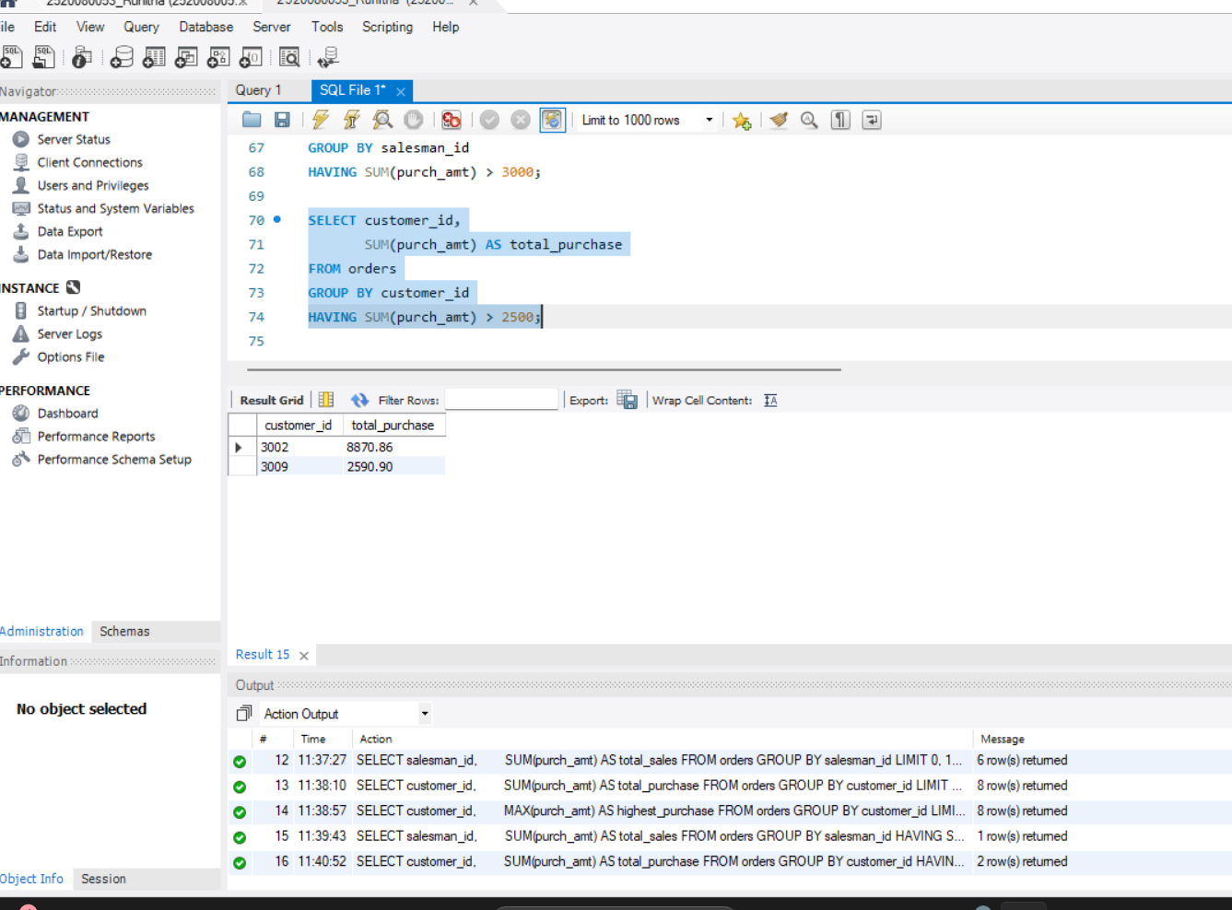
SCENARIO:
Find customers who placed more than one order.

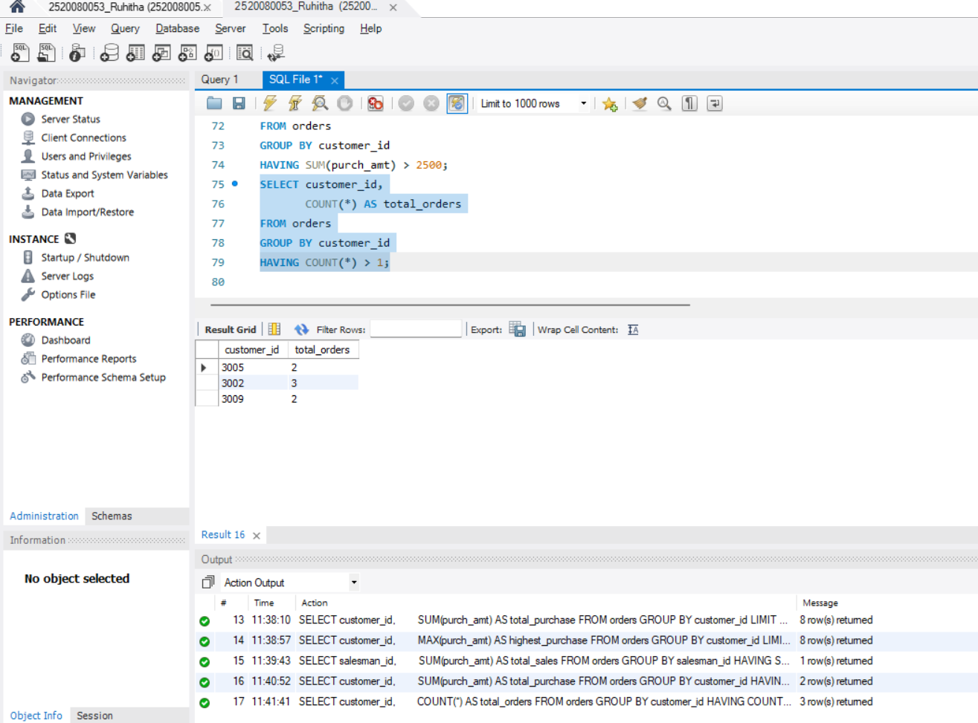
SCENARIO:
Management wants top customers ranked by spending.
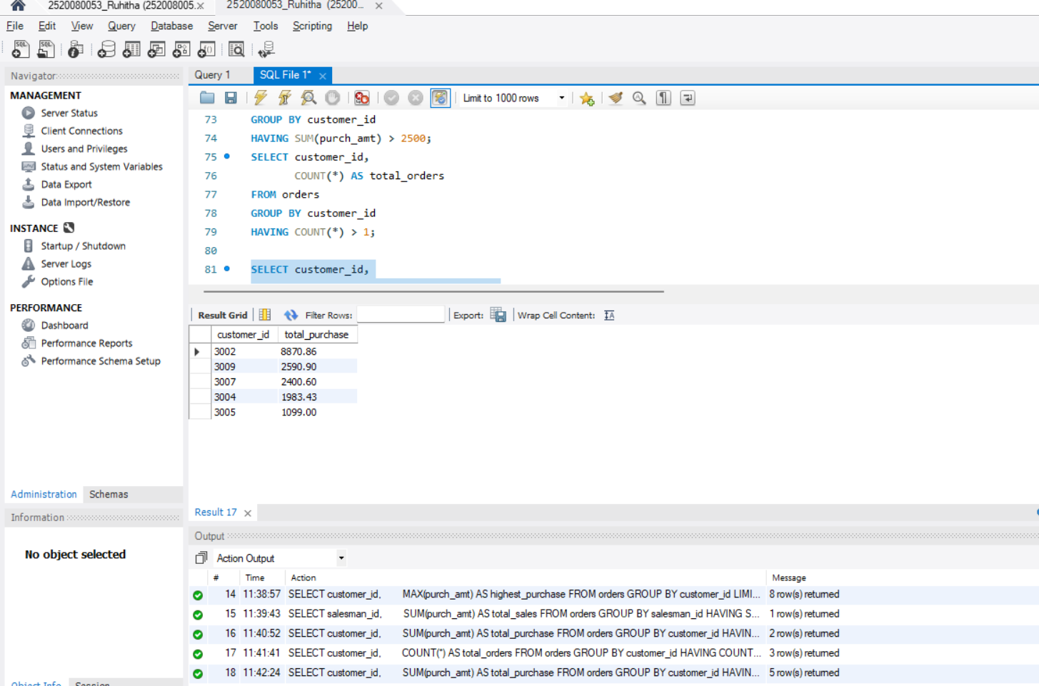
SCENARIO:
Find customers whose maximum purchase is between $2,000 and $6,000.
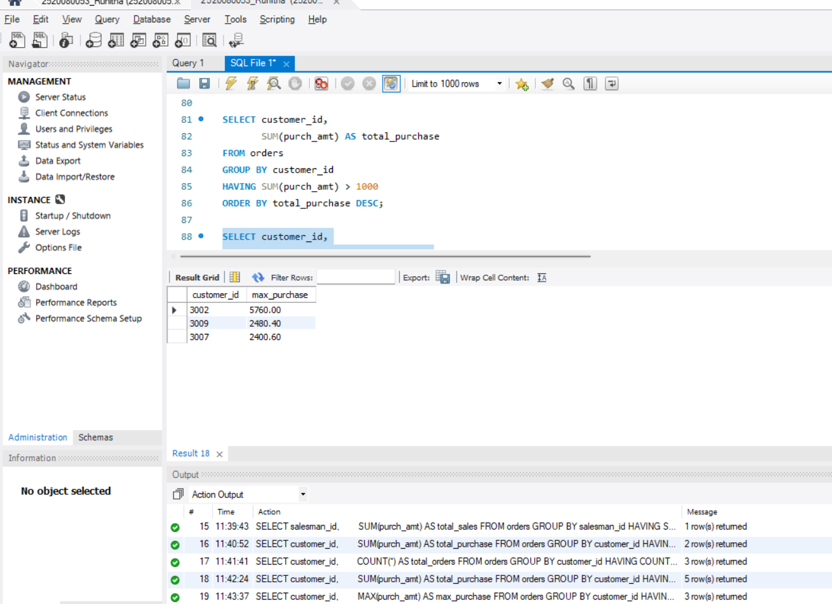
SCENARIO:
Find salesmen who handled at least two orders.

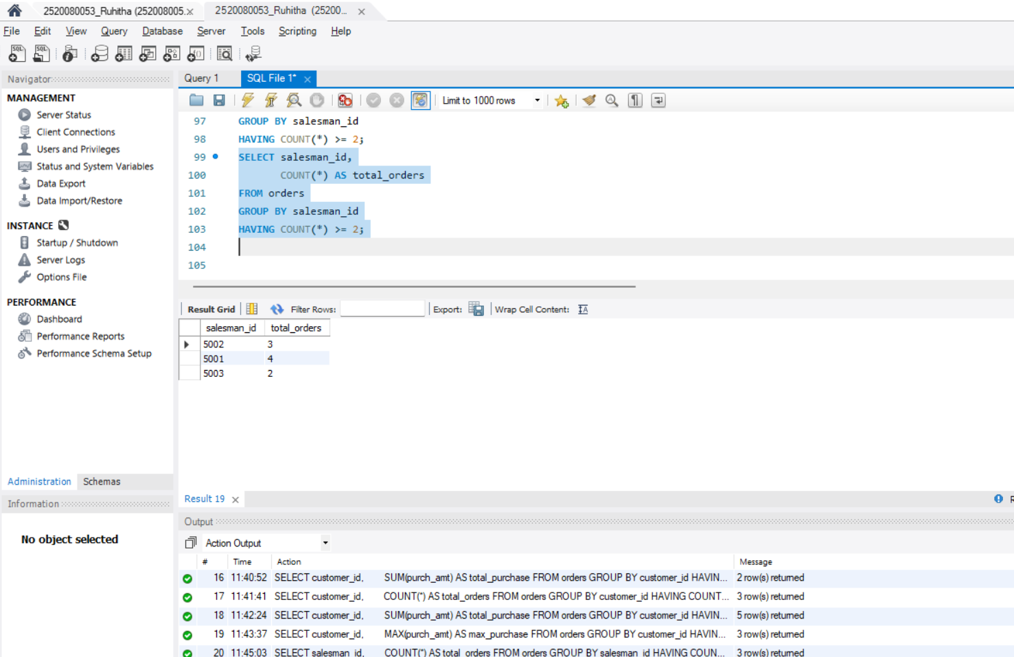
SCENARIO:
Management wants daily highest purchases above $2,000.
